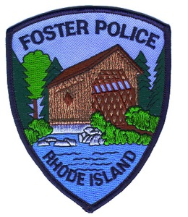
Foster Police Department
RABIES WARNING
On 09-29-17 the Rhode Island Department of Health notified Scituate Animal Control that a feline kitten that had bitten and scratched four individuals has tested positive for rabies.
On 09-28-17 the individuals located the stray feline kitten on Balcom Rd near Danielson Pike in Foster. The individuals related the feline kitten was acting strange and attempted to pick up the kitten to take it to the pound. During the capture all four individuals were bitten and or scratched.
The Rhode Island Department of Health and the Foster Police Department request residents in the area to monitor their pets and do not attempt to pick up any stray animals.
If any other person has come in contact with a stray and has been bitten or scratched they should call the Foster Police Department for further instructions.
If you see any animals exhibiting signs of odd behavior, please do not approach and are asked to call the Foster Police immediately.
If you have any questions call the Foster Police at 401-397-3317

